University of Pittsburgh at Johnstown
Department of Electrical and Computer Engineering
EE 1195 / COE 1195 Engineering Practice and Professional Development
Monthly Progress Report - 01

Cycle Statistic Tool

Date: February 3rd, 2021

Submitted By: Jacob Hoffman
Cody Klingler

Instructor: Professor Gabany
Professor Karunaratne

Project Description:
The Cycle Statistic Tool is a data recording device which will be attached to the frame of a bicycle. In this position, several electronic components may be used to record statistics about a user’s cycling trip. The Cycle Statistic Tool will transmit data to a companion application that is installed on a user’s smartphone. This application will utilize the collected information to provide records of a user’s cycling sessions in the form of graphs and charts that enable the user to improve their cycling skills. An appropriate microcontroller will be used as the primary board to connect all sensors and for operation of the device. A secondary microcontroller will be attached to the pedal shaft to wirelessly relay data from this position to the primary board. Live data will be displayed to the user by a display panel connected to the primary board. The entire device will require a casement which will be modeled and 3D-printed. This casement should be weather-proof and able to connect to the frame/handlebar of a bicycle universally.

Time Schedule:
Table 1 presents the task division table which provides appropriate start dates, end dates, and estimated time duration for each task to complete the Cycle Statistic Tool within the appropriate time frame. The completed tasks are highlighted green and include the actual time for completion.

Table 1: Task Division Table
Critical | Task Description | Duration | Start Date | End Date
 | Research Components | 6 hrs | Wed 1/20/21 | Fri 1/22/21
 | Research Bluetooth | 6 hrs | Wed 1/20/21 | Fri 1/22/21
• | Design System | 6 hrs | Wed 1/20/21 | Fri 1/22/21
 | Design Wind Sensing Unit | 9 hrs | Wed 1/20/21 | Sat 1/23/21
 | Research Data Analysis | 6 hrs | Sat 1/23/21 | Mon 1/25/21
• | Research Mobile Development | 10 hrs | Sat 1/23/21 | Fri 1/29/21
 | Research Data Analysis | 6 hrs | Fri 1/29/21 | Mon 2/1/21
 | Assemble Wind Sensing Unit | 13 hrs | Mon 1/25/21 | Mon 2/1/21
• | Design Mobile Application | 8 hrs | Fri 1/29/21 | Mon 2/1/21
 | Research Data Collection | 8 hrs | Fri 1/29/21 | Mon 2/1/21
 | Assemble Circuits | 11 hrs | Fri 1/29/21 | Wed 2/3/21
 | Test Components | 12 hrs | Fri 1/29/21 | Fri 2/5/21
 | Test Electrical Circuits | 19 hrs | Fri 1/29/21 | Mon 2/8/21
 | Mount Hardware | 12 hrs | Fri 2/5/21 | Fri 2/12/21
 | Weatherproof | 3 hrs | Fri 2/12/21 | Sat 2/13/21
 | Code Microcontrollers | 42 hrs | Fri 1/29/21 | Mon 2/22/21
 | Design Display UI | 4 hrs | Mon 2/22/21 | Wed 2/24/21
• | Code Mobile Application | 42 hrs | Wed 2/3/21 | Fri 2/26/21
• | Test Bluetooth Communication | 8 hrs | Sat 2/27/21 | Wed 3/3/21
 | Test Accuracy | 13 hrs | Fri 3/5/21 | Fri 3/12/21
 | Test Durability | 6 hrs | Fri 3/12/21 | Mon 3/15/21
• | Debugging | 42 hrs | Fri 3/5/21 | Sat 3/27/21

Green: Completed Tasks, Yellow: Tasks In Progress, Red: Incomplete Tasks
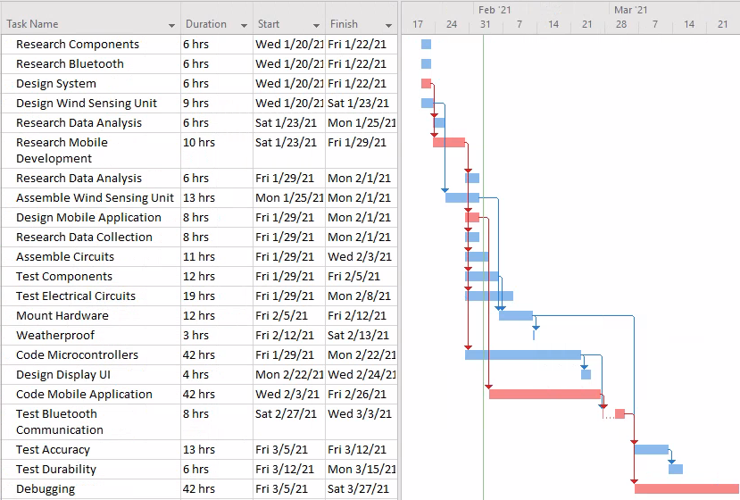
Figure 1: Gantt Chart

The majority of the time spent on the project in January consisted of research, design, and acquiring hardware. Based on the bill of materials (table 2), the following components were researched, ordered, and received:

Table 2: Bill of Materials

Part Number | Product Name | Quantity | Actual Cost | Description
ABX00027 | Arduino Nano 33 IOT | 2 | $18.40 | Microcontrollers with Bluetooth
Adafruit PID: 4224 | Adafruit eInk Breakout Friend with 32KB SRAM | 1 | $8.50 | Memory buffer for eInk display
Adafruit PID: 4262 | 2.9" Flexible Monochrome eInk | 1 | $26.95 | Low power eInk display
C000160 | Grove - Infrared Reflective Sensor V1.2 | 2 | $5.90 | Measures angular frequency
CEA-06-125UT-350 | Micro Measurements Strain Gages | 1 | $29.99 | Measures sheer force
176SF1D-L394 | Honeywell Precision Continuous 10K Potentiometer | 1 | $22.95 | Measures wind angle
PA1010D | Adafruit Mini GPS | 1 | $29.95 | 10Hz GPS module
LP785060 | Lithium Ion Polymer Battery - 3.7v 2500mAh | 1 | $14.95 | Power for Microcontrollers
 | Misc |  | $22.09 | Jumpers, Headers, Solder
 | Shipping |  | $35.99
TOTAL |  |  | $215.67

All major components have been acquired for the assembly of the Cycle Statistic Tool, except an additional lithium ion battery to power the secondary microcontroller while attached to the bicycle. However, a single battery will allow for the development and testing of the project until the project team is ready to mount the hardware onto the bicycle. Some miscellaneous purchases are expected to be required such as mounting brackets for the hardware and materials for constructing the stabilizer component of the wind angle fin. In addition to researching and ordering components, bluetooth communications and mobile development were also researched with respect to the project. Some time was spent in setting up the Microsoft Visual Studio IDE for using Xamarin.Forms for cross-platform mobile application development. Additionally, emulation of AndroidOS and iOS had to be set up and tested. Finally, the design of the electrical circuits was completed. The project team expects potential revisions to the circuit design to take place during the debugging stage.

Unexpected Items:
The anemometer, which is made from a CPU fan, can be measured by the Arduino, but causes intermittent crashes. This unexpected item has yet to be resolved. Cody soldered the headers onto the microcontroller backwards, so new headers had to be ordered and resoldered..
Jacob had issues simulating AndroidOS through the Visual Studio IDE. The latest Android API would not allow for the sample project to be installed and run. A solution was found by using Android 10 instead of Android 11 (latest version). Because Android is backwards compatible, simulating a slightly older version for the project should not cause any further issues.

Customer (Functional) Requirements and Engineering Specifications Targets:
The Engineering Specifications Table is presented in Table 3. There were no changes made to the table. Apart from cost of materials, the project is not in a state where any of the engineering specifications targets/thresholds can be evaluated. The total cost of materials so far is $215.67 and a breakdown of this figure can be seen in Table 2. This is well below our target cost of $500. Although there are some materials that need to be acquired, the project team believes the total cost of materials will end up below our target.

Table 3: Engineering Specifications Table
Engineering Specification | Unit | Direction | Target | Threshold
Size  Ease of use | m³ | ▼ | .2 | .5
Overall Accuracy of Sensors  Accuracy of measurements  Price  Battery life | % | ▲ | 90 | 80
Accuracy of Power Metric  Accuracy of measurements  Price  Battery life | % | ▲ | 90 | 75
Accuracy of Speed Metric  Accuracy of measurements  Price  Battery life | % | ▲ | 95 | 85
Cost of Materials  Accuracy of Measurements  Price  Battery life  Durability | $ | ▼ | 500 | 700
Weatherproof  Price  Weatherproof  Durability | IP | ▲ | 23 | 54
Battery Life  Price  Battery life | hr | ▲ | 12 | 3
Lifespan  Weatherproof  Durability | mo | ▲ | 24 | 12
Time to View Metrics in App  Statistic utilities in app | s | ▼ | 2 | 6
Setup Steps Before Use  Attaches universally  Ease of use  Ease of setup |  | ▼ | 3 | 6
Steps to Attach to Bike  Attaches universally  Ease of use  Ease of setup |  | ▼ | 10 | 20

